LHS Building Trades Program 2006-2020

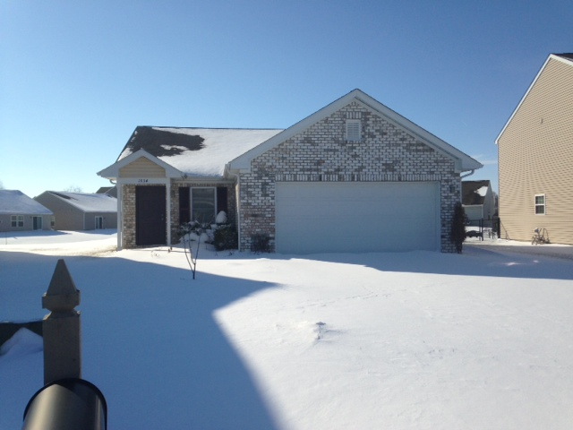

House 1: 2006-2007 1534 Round Lake Court

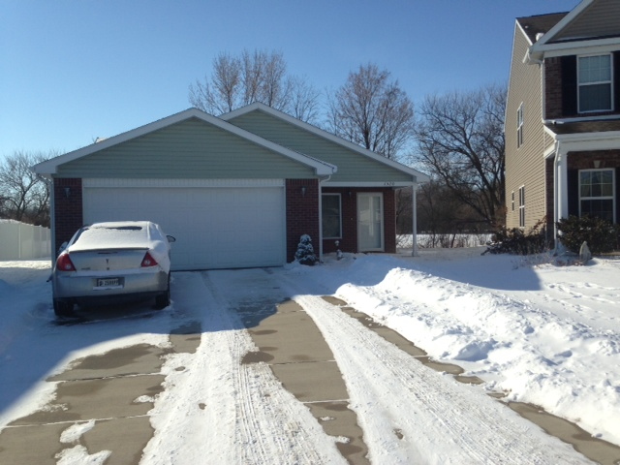

House 2: 2007-2008 1520 Vista Cove Court

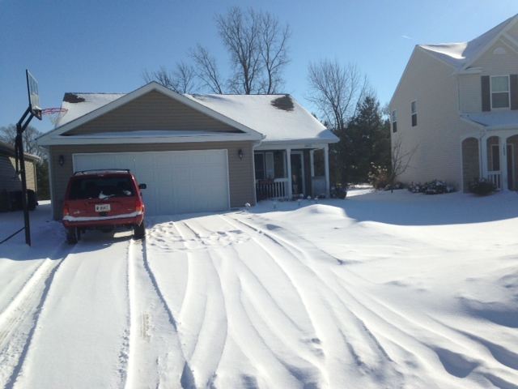

House 3: 2008-2009 1606 Jaques Drive

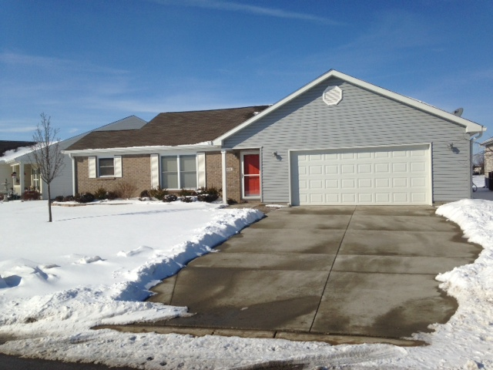

House 4: 2009-2010 1603 Jaques Drive
Instructor: Ken Acton 2013-Present

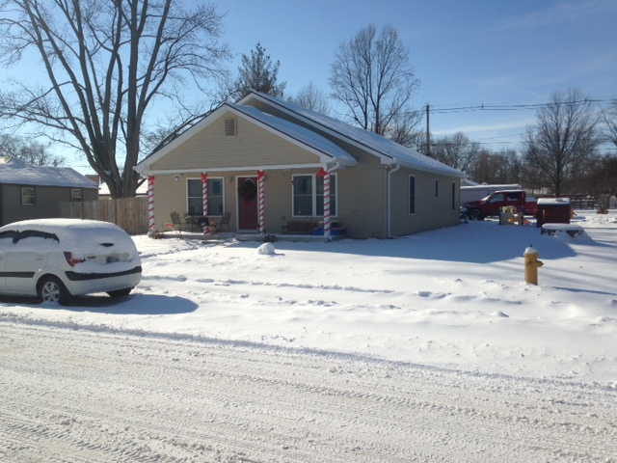

House 5: 2010-2011 824 Garfield Street

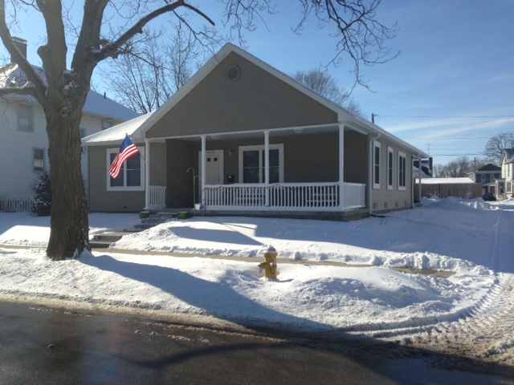

House 6: 2011-2012 412 N. Meridian Street

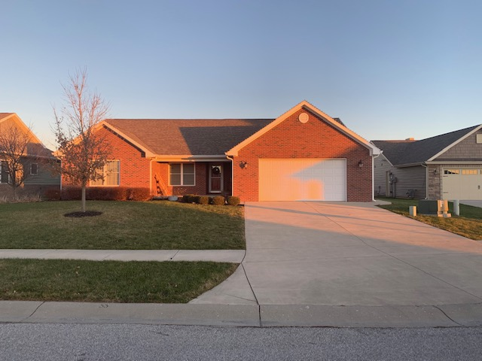

House 7: 2012-2013 2915 Detford Court

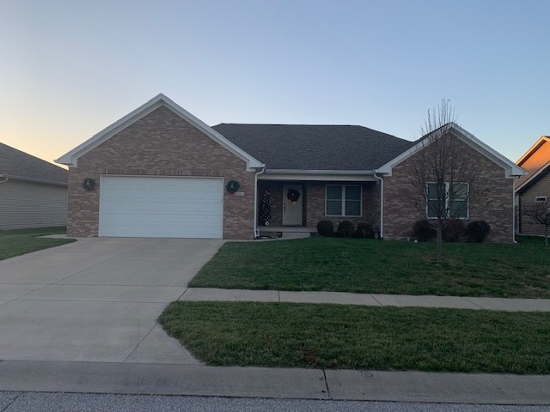

House 8: 2013-2014 2916 Lilly Drive
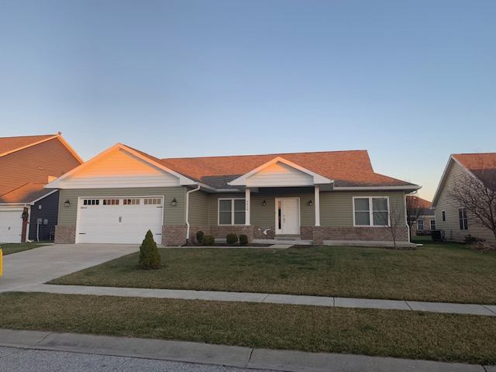

House 9: 2014-2015 2919 Detford Court

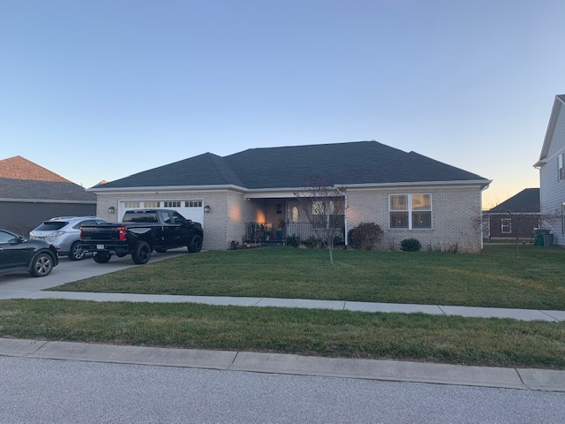

House 10: 2015-2016 809 Trillium Street

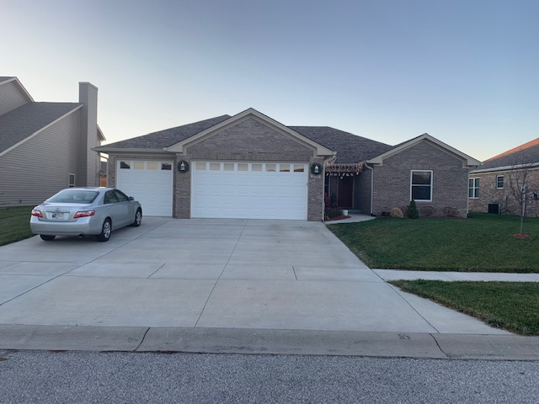

House 11: 2016-2017 2912 Lilly Drive

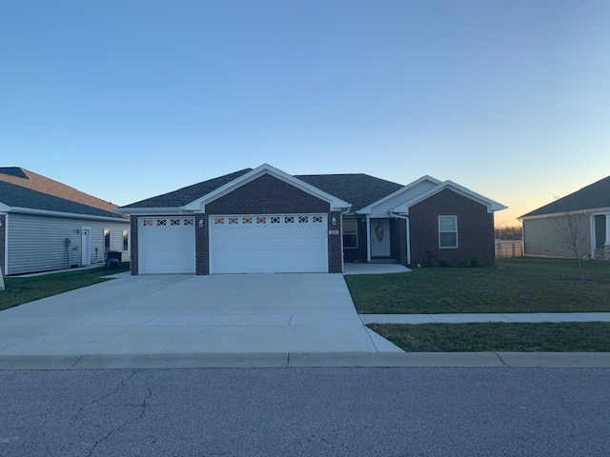

House 12: 2017-2018 725 Trillium Street

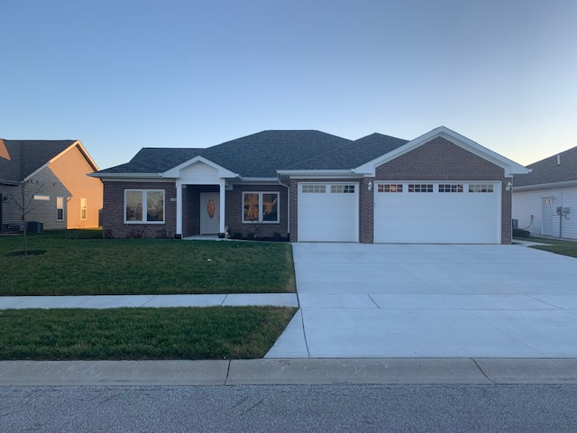

House 13: 2018-2019 731 Trillium Street

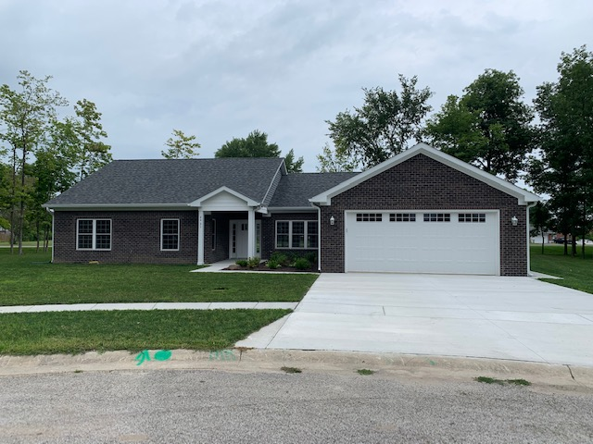

House 14: 2019-2020 2431 Oakbend Court

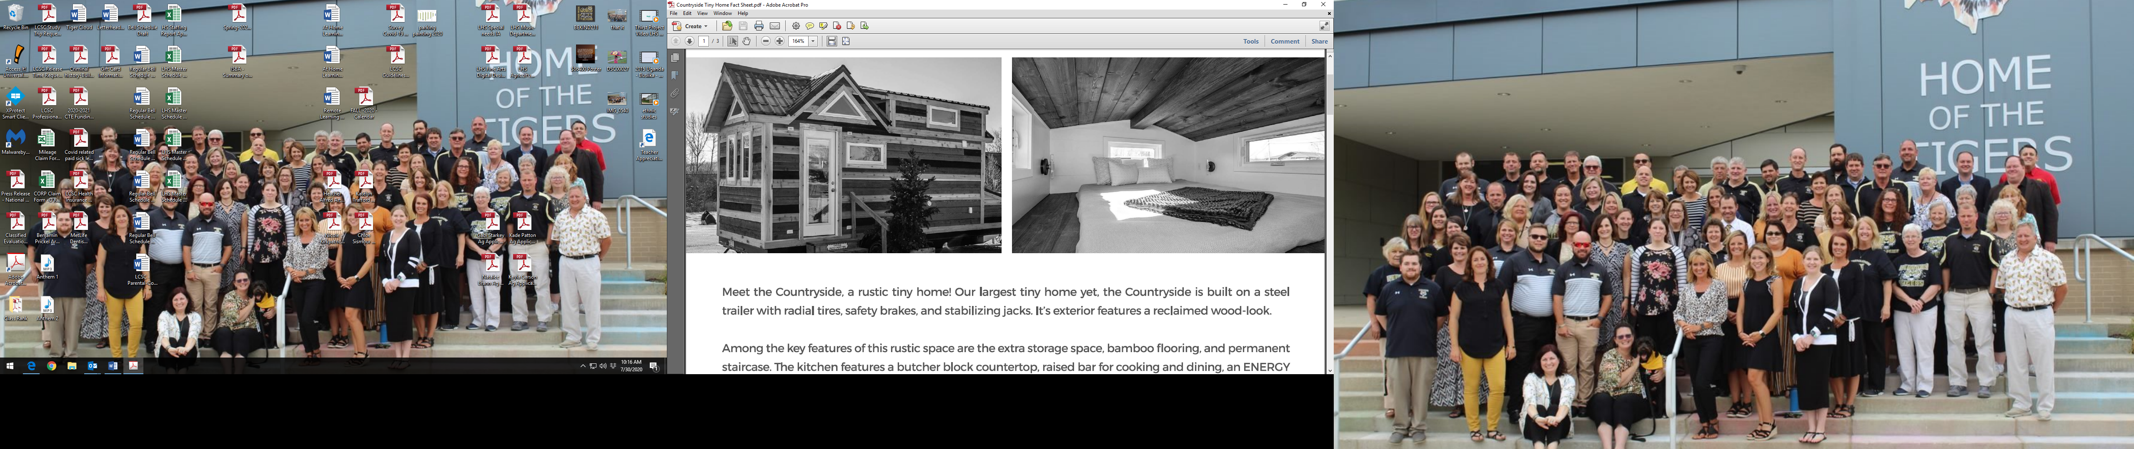

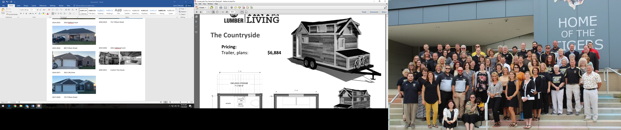

House 15: 2020-2021 Custom Tiny House

